PRESS RELEASE

***DARWIN IN PARADISE CAMP:***

***YUKI KIHARA***

***Did Darwin deceive us? A new exhibition at the Sainsbury Centre highlights research suggesting key findings on non-heteronormative species and same-sex attraction were tweaked to conform to 19th century morality.***

**A new exhibition at the Sainsbury Centre exploring the question:**

***Can the Seas Survive Us?***

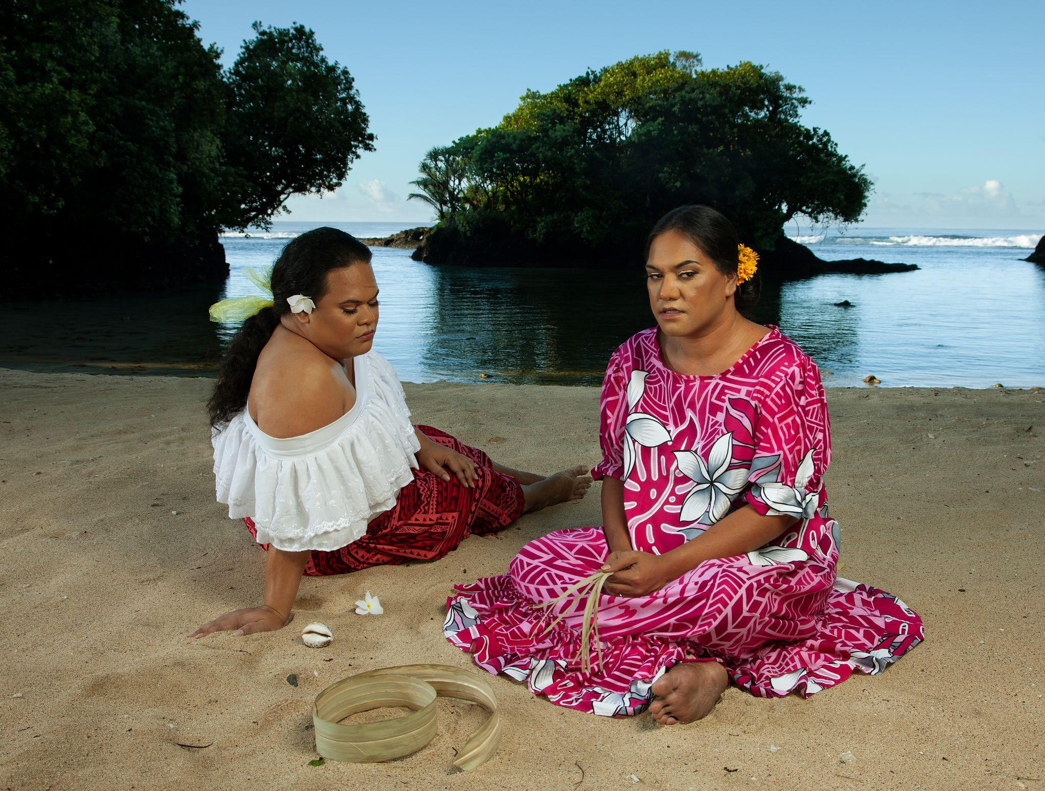

Yuki Kihara, *Two Fa'afafine on the Beach (after Gauguin)*, 2020, c-print. Copyright: Courtesy of Yuki Kihara

and Milford Galleries, Aotearoa New Zealand

**15 March 2025 – 3 August 2025**

**Sainsbury Centre, Norwich**

**The Sainsbury Centre presents *Darwin in Paradise Camp*, a new exhibition by Yuki Kihara (b.1975), an interdisciplinary artist of Sāmoan and Japanese descent. The exhibition features the UK premiere of *Paradise Camp (2022),* a photographic series first presented at the Aotearoa New Zealand Pavilion in the 59th Venice Biennale in 2022, alongside original works by Paul Gauguin and a newly commissioned video work, *Darwin Drag* (2025).**

Kihara’s practice is rooted in archival research and draws attention to the detrimental effects of climate change in the Pacific Islands. Responsible for less than 0.02% of global greenhouse gas emissions, Pacific Islanders’ proximity to the sea means they are amongst the most vulnerable to changing weather conditions. In particular, Kihara highlights the impacts of climate change on Sāmoa’s most vulnerable inhabitants: the third gender communities Fa’afatama and Fa’afafine, to which the artist also belongs.

Previously presented at the Aotearoa New Zealand Pavilion in the 59th Venice Biennale in 2022, *Paradise Camp* upcycles the works of French painter Paul Gauguin (1848–1903). Through archival research, Kihara believes Gauguin’s paintings made during his time in Tahiti and the Marquesas Islands were inspired by colonial photographs taken in Sāmoa.

In *Paradise Camp*,Kihara recasts past narratives by using Fa’afafine and Fa’afatama models in colourful, hyperreal photographs reflecting Gauguin’s compositions. This exhibition at the Sainsbury Centre will present the work alongside original works by Gauguin for the very first time.

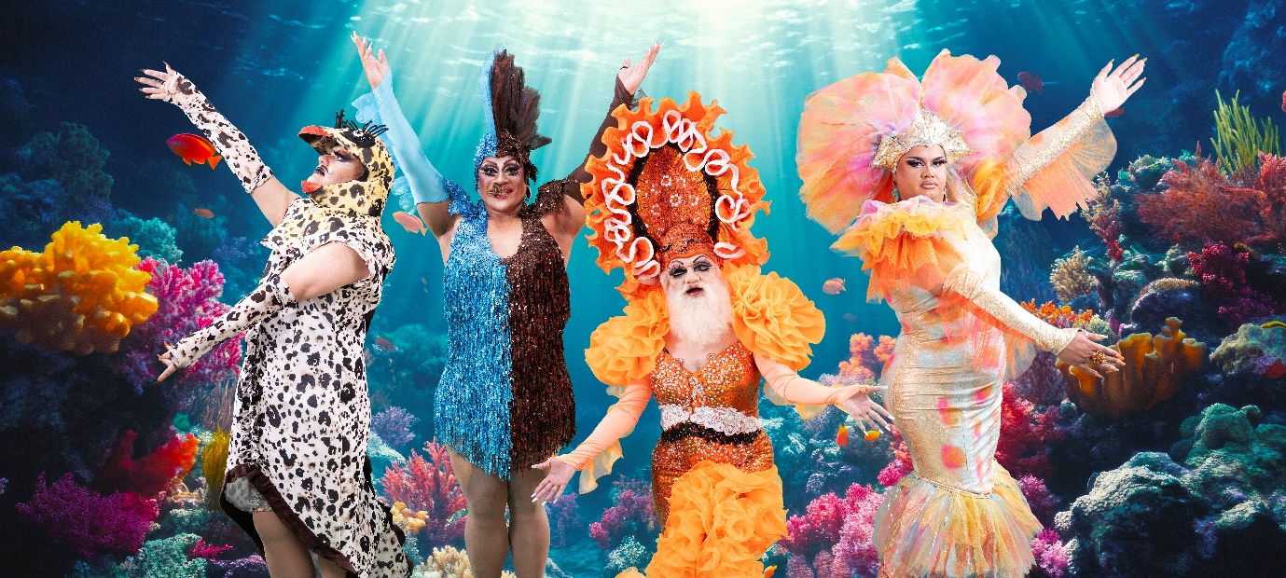

*‘Darwin Drag’ (2025) single channel video by Yuki Kihara. Courtesy of Yuki Kihara and Milford Galleries, Aotearoa New Zealand. Supported by the Sainsbury Centre, Creative New Zealand, British Council and the Whitworth, University of Manchester*

*Paradise Camp* will be augmented by Kihara’s ground-breaking new video work, *Darwin Drag* (2025).  Following new research by writers such as Ross Brooks and Joan Roughgarden, Kihara’s project reveals how famed evolutionary biologist Charles Darwin (1809–1882) manipulated some of his findings to suggest non-heteronormative species and same-sex attraction in animals was rare and unnatural, in order to conform with the conservative values of the Victorian period.

Darwin’s evolutionary theories and queer aesthetics in the animal ‘queendom’ inspired Kihara to create *Darwin Drag*, which features Kihara herself prosthetically transformed as Charles Darwin, who confides in a renown Sāmoan drag queen, BUCKWEAT, that he has been unhappy keeping his secret in the closet about queer species for so long.

*Darwin Drag*will also introduce the fish species with ‘Fa’afafine traits’ found in the ocean surrounding the Sāmoan archipelago, including clownfish and parrotfish. The work will be presented alongside corresponding fish specimens, on loan from the Natural History Museum. Incorporating wallpaper, Kihara’s own works, historical artworks and specimens plus archival material, the exhibition sheds new light on figures of the past and celebrates the radical perspective of this important artist.

The exhibition foregrounds how a closer relationship between humanity and the seas can save the communities most at risk of the human-caused impact on the seas, as well as the seas themselves.

Tania Moore, Head of Exhibitions at the Sainsbury Centre said: “Yuki Kihara has a unique voice in the art world today and can bring to light hidden histories and undertold stories. Through her practice, Kihara urges us to work together to care for each other and the planet.”

*Darwin in Paradise Camp: Yuki Kihara* is one of three concurrent exhibitions in a programme exploring the question *Can the Seas Survive Us?*, which charts a course through the story of the world’s oceans and the precarious future they may be heading towards.

*Can the Seas Survive Us?* examines the choices shaping our future due to climate change, while emphasising the vital importance of the oceans and the life beneath the waves for the viability of our shared future. The exhibitions *A World of Water* (15 March 2025 – 3 August 2025)*, Darwin in Paradise Camp: Yuki Kihara* (15 March 2025 – 3 August 2025) and *Sea Inside* (7 June – 26 October 2025) consider the seas’ fluidity as a powerful metaphor for navigating a way through turbulent times.

*Darwin in Paradise Camp: Yuki Kihara* will tour to the Whitworth, The University of Manchester, from 3 October 2025 – 1 March 2026.

*Supported by: British Council and AHRC Impact Acceleration Account administered by UEA.*

*Artist’s practice supported by Creative New Zealand.*



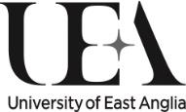

**NOTES TO EDITORS**

**For more information, interviews and images:**

Kate Wolstenholme

PR and Media Officer at the Sainsbury Centre

k.wolstenholme@uea.ac.uk

Phone: 01603 592470

[IMAGES CAN BE FOUND IN THIS LINK.](https://www.dropbox.com/scl/fo/xeat15ji5dgsodi3t29rm/ABhVip1SZaPaLEj_6EDCoX0?rlkey=2gt1wnpzq9jd43zrs2zs3lppn&st=chypalzo&dl=0)

**Exhibition details**

*Darwin in Paradise Camp: Yuki Kihara*

15 March 2025 – 3 August 2025

Sainsbury Centre, University of East Anglia,

Norfolk Road,

Norwich NR4 7TJ

**The Sainsbury Centre continues its innovative series of investigative exhibitions in 2025 with a new programme that charts a course through the story of the world’s oceans and the precarious future they may be heading towards.**

Three concurrent exhibitions explore *Can the Seas Survive Us?,* examining the choices shaping our future due to climate change, while emphasising the vital importance of the oceans and the life beneath the waves for the viability of our shared future.

Featured exhibitions:

* ***A World of Water***, 15 March – 3 August 2025
* ***Darwin in Paradise Camp: Yuki Kihara***, 15 March 2025 – 3 August 2025
* ***Sea Inside***, 7 June – 26 October 2025

**Opening times**

Tuesday – Friday 9am-6pm (exhibitions open 9.30am)

Saturday – Sunday 10am-5pm

Closed Mondays, including bank holidays

**Entry**

A Universal Ticket grants access to the permanent collection, lower and mezzanine galleries, and Sculpture Park. Tickets operate on a ‘Pay If and What You Can’ basis, so you can choose the price from free through to full membership.

**Yuki Kihara** is an interdisciplinary artist of Japanese and Sāmoan descent working and living in Sāmoa. Through a research-based approach, her practice seeks to challenge the dominant and singular historical narratives and their persistence in the socio-political climate; while often referencing the language of cultural traditions in her native land through a wide range of media, including performance, sculpture, video, photography, and curatorial practice.

Kihara’s exhibition highlights include the Gwangju Biennale (2023), the Aotearoa New Zealand Pavilion at the 59th Venice Biennale (2022), Aichi Triennale (2022), Bangkok Art Biennale (2018), Honolulu Biennale (2017), Asia Pacific Triennial (2015 and 2002), Sakahàn Quinquennial (2013), and the solo show *Living Photographs* at the Metropolitan Museum of Art, New York (2008). Her work can be found in over 30 permanent collections, including Museum of Modern Art, New York; Metropolitan Museum of Art, New York; Los Angeles County Museum of Art, Los Angeles; British Museum, London; National Museum of World Cultures, The Netherlands; National Museum of Scotland, Edinburgh; Sunpride Foundation, Hong Kong; Queensland Art Gallery, Brisbane; Kaohsiung Museum of Fine Arts, Taiwan; and Te Papa Tongarewa Museum of New Zealand.

In 2021, Kihara became a recipient of the Art Laureate Award from the Arts Foundation of New Zealand Te Tumu Toi. Kihara was a research fellow at the National Museums of World Cultures in The Netherlands from 2017 to 2022, and is currently an affiliate of Ecological Art Practices, a research cluster led by THE NEW INSTITUTE Centre for Environmental Humanities (NICHE) at the Ca ‘Foscari University of Venice (2022–2024).

**The Sainsbury Centre** is a world-class art museum with a unique perspective on how art can foster cultural dialogue and exchange. Following a radical relaunch in 2023 the Sainsbury Centre is the first museum in the world to formally recognise the living lifeforce of art, enabling people to build relationships across an arts landscape.

The art of the Sainsbury Centre can help reframe and answer the most important questions people have in their lives. It is not a museum to only learn more about artists, cultures or movements like Francis Bacon, the Tang Dynasty or Modernism, it is a place of experience, where collections are animate, and visitors are emotionally connected.

One of the first museums in the world to display art from all around the globe and from all time periods equally and collectively, Sir Robert and Lady Lisa Sainsbury created one of the most sought after yet non-conformist art collections. In 1973 they donated their collection, which transcended traditional barriers between art, architecture, archaeology and anthropology, to the UEA, and created an entirely new type of museum. Housed in Sir Norman Foster’s revolutionary first ever public building, the space aimed for an interactive relationship between people, object and landscape, where art was placed within an open yet intimate ‘living area’.

Visit [www.sainsburycentre.ac.uk](http://www.sainsburycentre.ac.uk) and follow @sainsburycentre on Facebook, X, Instagram and LinkedIn, as well as @TheSainsburyCentre on YouTube.