PRESS RELEASE

***A WORLD OF WATER***

**A new exhibition at the Sainsbury Centre exploring the question:**

***Can the Seas Survive Us?***

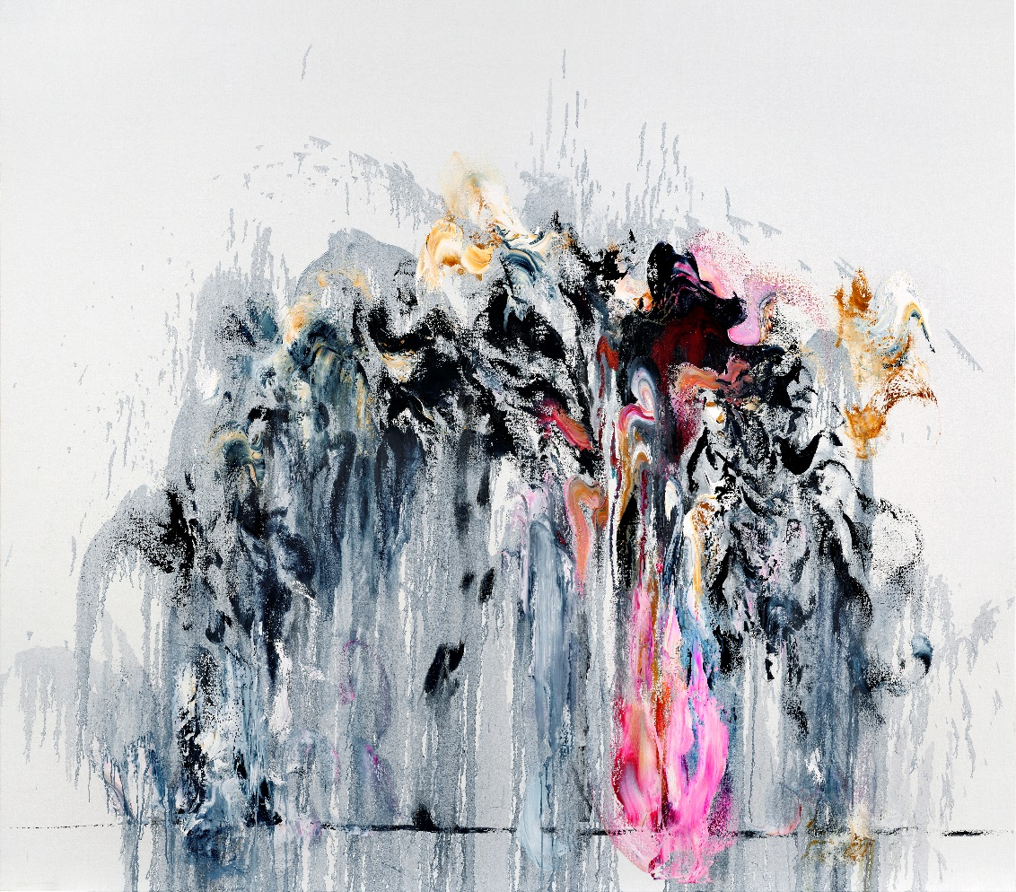

Maggi Hambling, *Wall of Water VIII*, 2011, oil on Canvas. Copyright: Maggi Hambling

**15 March 2025 – 3 August 2025**

**Sainsbury Centre, Norwich**

The Sainsbury Centre presents *A World of Water*, an exhibition exploring our shared and increasingly precarious relationship to the sea. Curated by John Kenneth Paranada, the first Curator of Art and Climate Change in a UK museum who, in early 2024, led a group of artists and researchers on a 36-hour journey by sea in pursuit of the question, “can the seas survive us?”; *A World of Water* shines a light on the collective, global effort to mitigate the impacts of climate change and to support action which restores marine ecosystems.

*A World of Water* is one of three concurrent exhibitions – *A World of Water*, *Darwin in Paradise Camp: Yuki Kihara* and *Sea Inside* – in a programme exploring the fundamental question *Can the Seas Survive Us?*, which brings together works and objects whose lives span great distances, both chronologically and geographically, to address critical contemporary issues around our connection to our planet, our seas, and each other.

The exhibition takes East Anglia’s deep maritime connections to the Low Countries of Europe as its starting point to look at the human impact on the interconnected seas that shape our world of water. Paranada led a group of artists, curators and activists on a 36-hour sailing voyage across the North Sea from Yarmouth to Rotterdam on board the Excelsior LT472, a 77-foot Lowestoft fishing smack built in 1921. The voyage was undertaken by Sainsbury Centre and Norwich University of the Arts researchers and artists in collaboration with the Nieuwe Instituut. The works shown in the exhibition bridges the past and present, revealing how the sea mirrors human experience of time and space, and shapes environments, cultural identities and collective anxieties.

Spanning works by British and international artists from as early as 1540 to the present day, *A World of Water* showcases some incredible artists who bring to life their unique perspectives of evolving marine ecosystems and oceanic habitats. It features works by historical and contemporary artists including Maggi Hambling (b.1945), Eva Rothschild (b.1971), Julian Charrière (b.1987), John Crome (1768–1821), Olafur Eliasson (b.1967), Josh Kline (b.1979), George Vincent (1796–1832), Hendricus Theodorus Wijdeveld (1885–1987), and many more.

Looking back to the cross-pollination between Norfolk and the Netherlands throughout the 16th century as its starting point, the exhibition presents maps and atlases dating back five hundred years, and includes seascapes typical of the Dutch Golden Age, tracing their influence through time to inspire the artists of the Norwich School in 19th-century East Anglia. Bringing together archival materials with historical and contemporary works – from turbulent seascapes to abstract representations of water’s dynamic forms – *A World of Water* traces the shift in artistic perceptions of the sea, from romanticised seascapes to urgent reflections on environmental crisis, adaptation and resilience.

**John Kenneth Paranada, Curator of Art and Climate Change at the Sainsbury Centre**, said: "What makes this exhibition urgent is its innovative and pioneering curatorial approach – one that amplifies lived experiences of climate realities, not as a distant future, but as a crisis already unfolding.”

“A World of Water charts shifting tides, vanishing coastlines, and the voices of communities on the frontlines of climate change. Spanning five centuries, it connects the North Sea to global waters, exposing how power structures shape ecological futures. As rising seas redraw maps and disrupt economies, the exhibition demands a reckoning: What must change to secure the future of our entangled seas?"

**Jago Cooper, Director of the Sainsbury Centre**, said: “The collective way the artists, curators, activists and storytellers have built this exhibition together is truly inspirational. They have created a spellbinding journey across the imaginative oceans of human innovation and hope.”

*Can the Seas Survive Us?* is the latest in an innovative series of investigative exhibitions by the Sainsbury Centre following its radical relaunch in 2023, when it became the first museum in the world to formally recognise the living lifeforce of art, enabling people to build relationships with living art across its dynamic museum landscape.

*Supported by: Arts Council England, Art Fund, The Dutch Embassy, John Ellerman Foundation, Hudson Architects.*



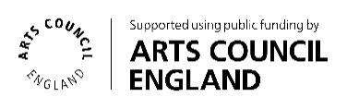

**NOTES TO EDITORS**

**For more information, interviews and images:**

Kate Wolstenholme

PR and Media Officer at the Sainsbury Centre

k.wolstenholme@uea.ac.uk

Phone: 01603 592470

[IMAGES CAN BE FOUND IN THIS LINK.](https://www.dropbox.com/scl/fo/tnmnalzu27lbhwykn9v7u/AJCQVQwVqHMwj01g6jahWuY?rlkey=u6e4rcbahpwd032o6r6w210t5&st=p6eubbgu&dl=0)

**Exhibition details**

*A World of Water*

15 March 2025 – 3 August 2025

Sainsbury Centre, University of East Anglia,

Norfolk Road,

Norwich NR4 7TJ

**The Sainsbury Centre continues its innovative series of investigative exhibitions in 2025 with a new programme that charts a course through the story of the world’s oceans and the precarious future they may be heading towards.**

Three concurrent exhibitions explore *Can the Seas Survive Us?,* examining the choices shaping our future due to climate change, while emphasising the vital importance of the oceans and the life beneath the waves for the viability of our shared future.

Featured exhibitions:

* ***A World of Water***, 15 March – 3 August 2025
* ***Darwin in Paradise Camp: Yuki Kihara***, 15 March 2025 – 3 August 2025
* ***Sea Inside***, 7 June – 26 October 2025

**Opening times**

Tuesday – Friday 9am-6pm (exhibitions open 9.30am)

Saturday – Sunday 10am-5pm

Closed Mondays, including bank holidays

**Entry**

Tickets operate on a ‘Pay Only If and What You Want’ basis, so you can choose the price from free through to full membership. A Universal Ticket grants access to the permanent collection, lower and mezzanine galleries, and Sculpture Park.

**The Sainsbury Centre** is a world-class art museum with a unique perspective on how art can foster cultural dialogue and exchange. Following a radical relaunch in 2023 the Sainsbury Centre is the first museum in the world to formally recognise the living lifeforce of art, enabling people to build relationships across a dynamic and interactive arts landscape.

The art of the Sainsbury Centre can help reframe and answer the most important questions people have in their lives. It is not a museum to only learn more about artists, cultures or movements like Francis Bacon, the Tang Dynasty or Modernism, it is a place of experience, where collections are animate, and visitors are emotionally connected.

One of the first museums in the world to display art from all around the globe and from all time periods equally and collectively, Sir Robert and Lady Lisa Sainsbury created one of the most sought after yet non-conformist art collections. In 1973 they donated their collection, which transcended traditional barriers between art, architecture, archaeology and anthropology, to the UEA, and created an entirely new type of museum. Housed in Sir Norman Foster’s revolutionary first ever public building, the space aimed for an interactive relationship between people, object and landscape, where art was placed within an open yet intimate ‘living area’.

Visit [www.sainsburycentre.ac.uk](http://www.sainsburycentre.ac.uk) and follow @sainsburycentre on Facebook, Bluesky, X, Instagram and LinkedIn, as well as @TheSainsburyCentre on YouTube.