

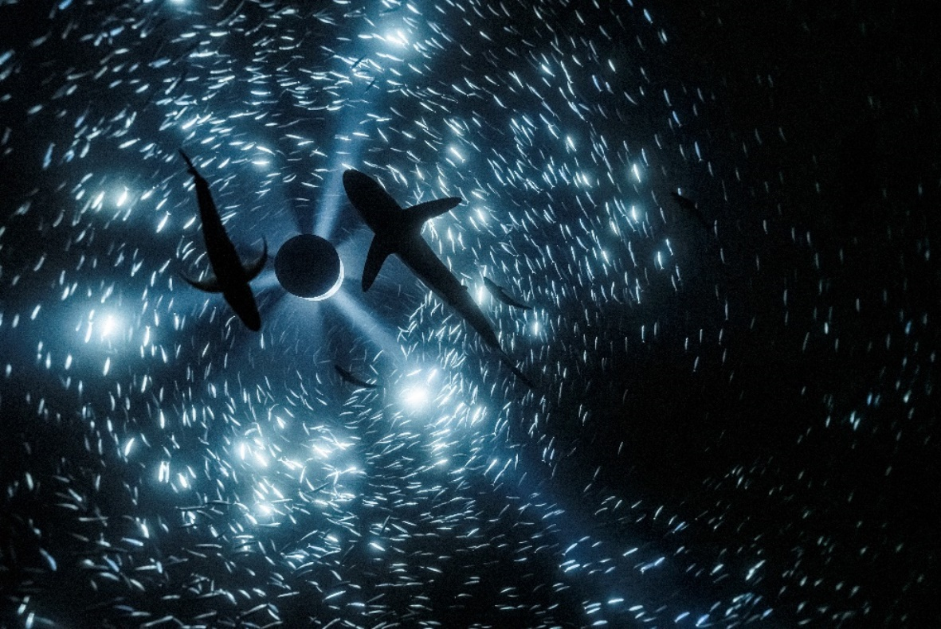

***CAN THE SEAS SURVIVE US?***

**The future of our oceans is explored in the Sainsbury Centre’s extensive 2025 exhibition programme**

**The Sainsbury Centre continues its innovative series of investigative exhibitions in 2025 with a new programme that charts a course through the story of the world’s oceans and the precarious future they may be heading towards.**

As sea levels rise, oceans are also warming, becoming more acidic and containing less oxygen. The United Nations describe the oceans as "overwhelmed" as humans overfish, pollute, and destroy habitats, with the ocean's health declining at an "alarming rate".

Featuring contemporary art, historical paintings, ancient atlases and maps from across the globe, the season explores humanity’s enduring and complex relationship with the sea. Three concurrent exhibitions explore *Can the Seas Survive Us?,* examining the choices shaping our future due to climate change, while emphasising the vital importance of the oceans and the life beneath the waves for the viability of our shared future.

Featured exhibitions:

* ***A World of Water***, 15 March – 3 August 2025
* ***Darwin in Paradise Camp: Yuki Kihara***, 15 March 2025 – 3 August 2025
* ***Sea Inside***, 7 June – 26 October 2025

This trio of exhibitions consider the seas’ fluidity as a powerful metaphor; ranging from our need to navigate a way through turbulent times, to champion and learn from Indigenous knowledge, seize the opportunities presented by the sea as a regenerative, sustainable energy source, recognising its relentless, destructive power in ways that are crucially felt and experienced by low-lying small island nations such as the Maldives and Kiribati, along with coastal communities, including several here in Norfolk.

***A World of Water***

**15 March – 3 August 2025**

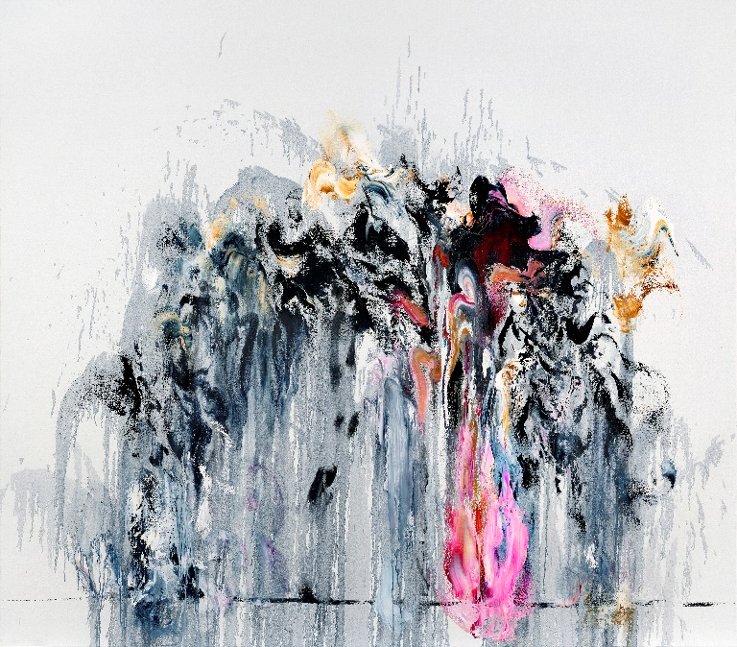A day at the seaside or rain at Wimbledon. So much of our shared experience of the British summer involves water. But what would the world be like without water, or more critically, without our seas and oceans and all the lifeforce within it? The Sainsbury Centre aims to unlock a sense of urgency, recognising that the precarious nature of our waters, and possible geopolitical conflicts caused by them, will be as significant in this century as oil was in the 20th.

*A World of Water* brings together works by British and international artists from as early as 1540 to the present day, who have all offered a unique perspective of evolving marine ecosystems and oceanic habitats. Taking the North Sea and the historical relationship between Norfolk and the Netherlands as its starting point, the exhibition looks at the human impact on the sea.

The exhibition encourages visitors to understand the complexity of sea and marine life, whilst encouraging a collective, global effort to mitigate the impacts of climate change and support action to restore marine ecosystems.

Featuring artworks by Maggi Hambling (b.1945), Eva Rothschild (b.1971), Julian Charrière (b.1987), John Crome (1768–1821), Olafur Eliasson (b.1967), Josh Kline (b.1979), George Vincent (1796–1832), Hendricus Theodorus Wijdeveld (1885–1987), and many more, *A World of Water* delves into humanity's profound and intricate connection with the sea, raising pivotal questions about the world’s governments’ responses to climate change, coastal erosion, and environmental degradation.

*Supported by:**The Dutch Embassy, Art Fund, John Ellerman Foundation, Hudson Architects.*

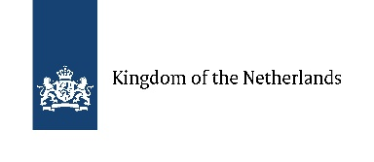

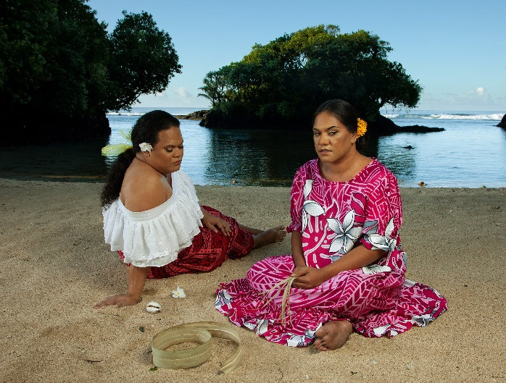***Darwin in Paradise Camp: Yuki Kihara***

**15 March 2025 – 3 August 2025**

The Sainsbury Centre is proud to host the UK premiere of *Paradise Camp*, a celebrated work by Yuki Kihara (b.1975), an interdisciplinary artist of Sāmoan and Japanese descent, which will be exhibited alongside newly commissioned work titled *Darwin Drag*.

Previously presented at the Aotearoa New Zealand Pavilion in the 59th Venice Biennale in 2022, *Paradise Camp* upcycles the works of French painter Paul Gauguin (1848–1903). Through archival research, Kihara believes Gauguin’s paintings made during his time in Tahiti and the Marquesas Islands were inspired by colonial photographs taken in Sāmoa.

Kihara recasts past narratives by using Fa’afafine models – a third gender community in Sāmoa, to which Kihara also belongs – in colourful, hyperreal photographs reflecting Gauguin’s compositions. *Darwin in Paradise Camp* will feature original works by Gauguin alongside Kihara’s *Paradise Camp* for the very first time.

*Paradise Camp* will be augmented by Kihara’s ground-breaking new work, *Darwin Drag.* Following new research by Ross Brooks, Kihara’s project, which reveals how famed evolutionary biologist Charles Darwin (1809–1882), shaped some of his findings and suggested non-heteronormative species and same-sex attraction in animals was rare and unnatural, to conform with the conservative values of the Victorian period.

Darwin’s evolutionary theories and queer aesthetics in the animal ‘queendom’ inspired Kihara to create *Darwin Drag* – a video work featuring Kihara herself prosthetically transformed as Charles Darwin, who confides in a renown Sāmoan drag queen, BUCKWEAT, that he has been unhappy keeping his secret in the closet about queer species for so long.

*Darwin Drag*will also introduce the fish species with ‘Fa’afafine traits’ found in the ocean surrounding the Sāmoan archipelago, including clownfish and parrotfish. *Darwin Drag* will be presented alongside corresponding fish specimens, on loan from the Natural History Museum.

Incorporating wallpaper, Kihara’s own works, historical artworks and specimens plus archival material, the exhibition will shed new light on figures of the past and celebrate the radical perspective of this important artist of today.

The exhibition foregrounds how a closer relationship between humanity and the seas can save the communities most at risk of the human-caused impact on the seas, as well as the seas themselves.

*Supported by: British Council and AHRC Impact Acceleration Account administered by UEA.*

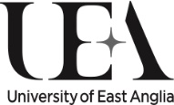

***Sea Inside***

**7 June – 26 October 2025**

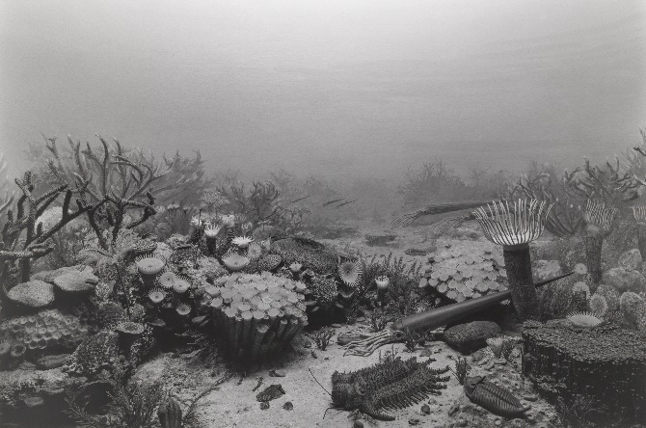Have you ever wondered what it feels like to live underwater, to be inside a shell, or even the belly of a whale?

Featuring experimental contemporary artworks across a range of media by artists including Shuvinai Ashoona (b.1961), Marcus Coates (b.1968), Evan Ifekoya (b.1988), Laure Prouvost (b.1978) and Hiroshi Sugimoto (b.1948), Dr Sarah Wade (University of East Anglia) and Dr Pandora Syperek (Loughborough University London) have curated a unique oceanic experience that explores humanity’s interconnections, interrelationships, and immersion in oceans.

While some humans have pursued life above or under water – through seafaring, research, fishing or diving – others have and still are subjected to the horrors of forced or desperate maritime crossings. Yet the sea has often been viewed as a mysterious ‘other’, with its expansive surface and seemingly infinite depths dominating marine imagery in the history of Western art. Conversely, artworks in this exhibition explore the ways the oceans have been domesticated, reimagined on a bodily scale and brought inside to be tamed, contained or better understood.

*Sea Inside* turns our oceanic gaze towards the sea’s more intimate spaces – whether physical, psychological or imaginary – and dives into shared watery origins, Indigenous ways of life and the items we remove from the sea to display on land.



***De Onkruidenier***

De Onkruidenier will carry out a residency as part of the *Can the Seas Survive Us?* season, collaborating with Norfolk coastal communities to facilitate meaningful exchange and community activations. The Dutch collective, who describe themselves as Ecosystem Futurists, create new narratives to reinterpret the relationship between humans and nature, both above and below sea level.

Director of the Sainsbury Centre, Jago Cooper, says: *“The oceans cover more than 70% of the planet; it is the life source of the natural world, an eternal expanse of more than a billion cubic kilometres of marine habitat. Yet what do these seas say about the state of nature today and our relationship with it? From wind farms populating the North Sea and plastics filling the Pacific, to toxic algal blooms appearing and beautiful creatures disappearing, what really lies below the surface of these stories and ultimately:* Can the Seas Survive Us*?”*

**NOTES TO EDITORS**

[**HIGH RESOLUTION IMAGES FOR MEDIA USE CAN BE DOWNLOADED HERE**](https://www.dropbox.com/scl/fo/wcf4ymd17lh8pd41yxale/AEUD-L-dRGqNWGnFixd-w0s?rlkey=ym9ueq8typ2uquv9fmnrdi6l5&st=tn7byhw9&dl=0)

* Julian Charrière, *Midnight Zone*, 2024. Copyright the artist, VG Bild-Kunst, Bonn, Germany
* Maggi Hambling, *Wall of Water VIII*, 2011, oil on Canvas. Copyright: Maggi Hambling
* Yuki Kihara, *Two Fa'afafine on the Beach (after Gauguin)*, 2020, c-print. Copyright: Courtesy of Yuki Kihara and Milford Galleries, Aotearoa New Zealand
* Hiroshi Sugimoto, *Devonian Period*, 1992. Copyright: Hiroshi Sugimoto, courtesy of Lisson Gallery

**The Sainsbury Centre** is a world-class art museum with a unique perspective on how art can foster cultural dialogue and exchange. Following a radical relaunch in 2023 the Sainsbury Centre is the first museum in the world to formally recognise the living lifeforce of art, enabling people to build relationships across an arts landscape.

The art of the Sainsbury Centre can help reframe and answer the most important questions people have in their lives. It is not a museum to only learn more about artists, cultures or movements like Francis Bacon, the Tang Dynasty or Modernism, it is a place of experience, where collections are animate, and visitors are emotionally connected.

One of the first museums in the world to display art from all around the globe and from all time periods equally and collectively, Sir Robert and Lady Lisa Sainsbury created one of the most sought after yet non-conformist art collections. In 1973 they donated their collection, which transcended traditional barriers between art, architecture, archaeology and anthropology, to the UEA, and created an entirely new type of museum. Housed in Sir Norman Foster’s revolutionary first ever public building, the space aimed for an interactive relationship between people, object and landscape, where art was placed within an open yet intimate ‘living area’.

Visit www.sainsburycentre.ac.uk and follow @sainsburycentre on Facebook, X, Instagram and LinkedIn, as well as @TheSainsburyCentre on YouTube.

**FOR MORE INFORMATION, INTERVIEWS AND IMAGES**

Kate Wolstenholme

PR and Media Officer at the Sainsbury Centre

Email: k.wolstenholme@uea.ac.uk

Phone: 01603 592470

