

***WHY DO WE TAKE DRUGS?* The investigation continues**

**The second phase of the Sainsbury Centre’s ground-breaking series of exhibitions examining the highs and lows of drug cultures across the world opens this November**

In September (2024), the Sainsbury Centre boldly launched a six-month exhibition programme, seeking to address one of global society’s biggest questions, *Why Do We Take Drugs?*

The opening two exhibitions (open until February 2025) look at themes of the use and dependency to substances ranging from amphetamines and caffeine to ayahuasca and tobacco.

In the second half of the season (beginning 23 November), the Sainsbury Centre’s focus turns to the harsh realities of life as a heroin user and the more freely available and, perhaps controversially, socially acceptable reliance on antidepressants and alcohol.

***Heroin Falls***

**23 November 2024 – 27 April 2025**

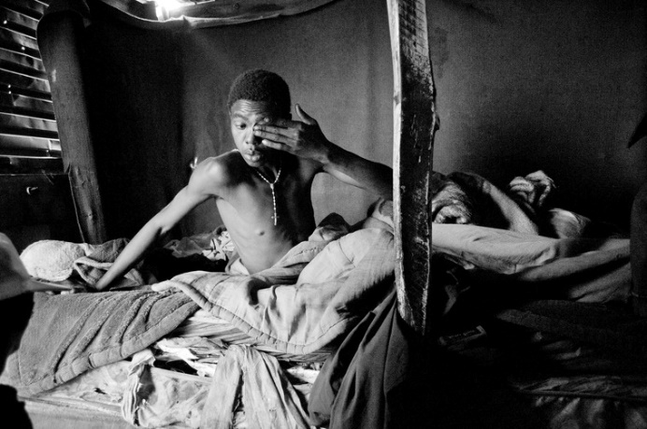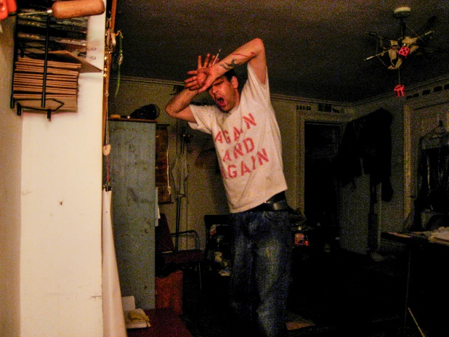

*Heroin Falls* unflinchingly reveals heroin dependency as seen through the eyes of two remarkable photographers.

The exhibition aims to show how substance use and dependency is a global challenge that transcends race, location and class.

Magnum photographer Lindokuhle Sobekwa (b.1995) aimed his lens at a group of young men living in the South African township of Thokoza, where they turned to using Nyaope, a low-grade form of heroin which can be mixed with many different bulking agents including cannabis products, antiretroviral drugs, as well as other materials.

Sobekwa documented their journey, capturing their daily activities and chores. He concluded the project by presenting a positive, redemptive aspect of their journeys through rehab and moments of reflection.

Sobekwa explains: *"My education in photography was not only based in school, where they teach you, but also in the people I photograph. The Nyaope project was really about the fragile family created out of circumstances, rather the biological family with the shack being a home to meet, smoke and have conversations. It was from allowing me as a photographer access to their space to take images and to know when to put the camera down, to talk and to know when to keep quiet.”*

While most documentary projects about dependency expose another person’s behaviour, Scottish-born, New York-based photographer Graham MacIndoe (b.1963) took a very different approach: he photographed himself during the years he was dependant on heroin. He'd place a cheap digital camera on a table or bookshelf, set the self-timer to take a photo every so often, then turn his attention to the rituals of his habit. The resulting images unflinchingly depict his drug dependency, along with his creative use of the medium to chart his own recovery.

MacIndoe has been in recovery for nearly 15 years, volunteering to help others access harm reduction, treatment, and recovery support and reduce the stigma surrounding people navigating dependency and other challenges. The exhibition will also include collaborative works from this series.

Describing his process, MacIndoe says: *"Even in that haziness of dependency and the surrounding chaos and disruption in my life, I was still thinking like a photographer. I was aware of the environments I was in, the way the light was, what angles to choose, and when to take the pictures. It just seemed very instinctive for me to start recording what I was going through.*

*“Initially, I had thought I could take pictures of other people taking drugs, but I gradually turned the camera on myself as a way to document dependency from the inside."*

***Lindsey Mendick: Hot Mess***

**23 November 2024 – 27 April 2025**

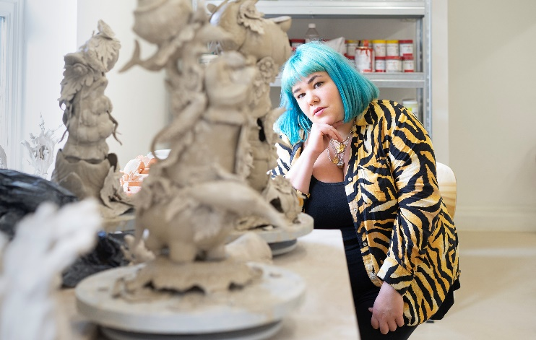Lindsey Mendick (b.1987) is an artist who subverts the tradition of ceramics with darkly comic, confessional works. Her newly commissioned series of sculptures especially for the Sainsbury Centre exhibition are strikingly personal, and tackle a number of social taboos while exposing Mendick’s own, secret fears.

For the *Why Do We Take Drugs?* season, Mendick, who recently won the Sky Arts award for Visual Art, has bravely revealed her relationship with antidepressants and alcohol, which she relied upon to help navigate stressful social situations and cope with the threatening unpredictability of daily life. In so doing, her subversive practice candidly addresses the stigma attached to taking medications, such as antidepressants, and confronts the viewer’s own possible behaviours.

By positioning her works amongst paintings by Francis Bacon and Leonora Carrington, along with sculpture from the Arctic to Africa, Mendick has created a surprising intervention in the Sainsbury Centre’s ‘Living Area’ collection display to disrupt the clean aesthetic, rather like an unruly and unwelcome guest at a party.

Mendick describes what inspired her artworks and title of her exhibition: “*Art is meant to be so varied and reflect so many different types of people, so why shouldn’t it reflect someone who struggles with their mental health like I have?*

*“I did an exchange in America with the Royal College of Art and I asked my friend, ‘How bad was I last night?’ And they were like, ‘Girl, you were a hot mess.’*

*“This is a self-portrait of how I am now, with the desperation to join the party and to get drunk, and the utter shame and self-loathing when I’ve lost my inhibitions and let myself go. I want the work to show the desperate attempts at trying to piece myself back together. That’s quite a lot of my life – continuously trying to piece myself back together, which is something that the antidepressants are meant to help you do. I think my work is like a cipher for the way I’d like to live. It has a boldness that I don’t think I can have.”*

**Sculpture Park Commission**

***Ivan Morison: Towards the Weird Heart of Things***

**Until 2 February 2025**

Linking the two phases of the exhibition is *The Reapers*, a new site-specific series of sculptures by artist Ivan Morison, created in response to the curatorial provocation, *Why Do We Take Drugs?*

The specially-commissioned work – presented in collaboration between the Sainsbury Centre and Orleans House Gallery, Twickenham – features sculptures constructed from abundant agricultural organic materials including hemp, straw, beans, and tomatoes. These materials, sourced from local harvests and combined with hay and coppiced timber from the Sainsbury Centre Sculpture Park, give the sculptures a haystack-like appearance.

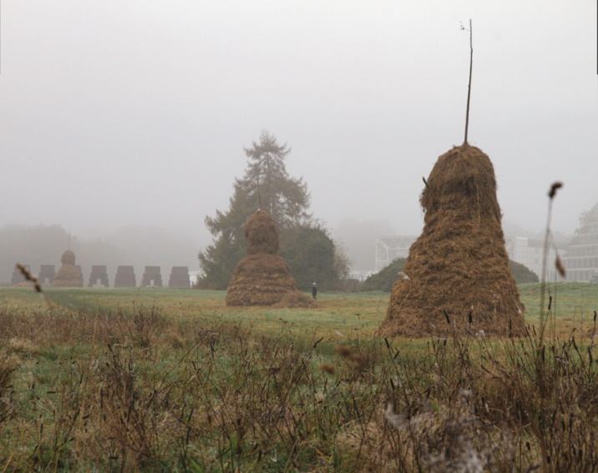

These four-meter-high sculptures in the Sainsbury Centre Sculpture Park are intended to ‘evolve’, and will variously change colour, transform, or decay and compost over time, challenging the permanence of traditional sculpture.

Morison’s works shine a light on the dichotomies that face farming communities today whilst also encouraging visitors to the show to reassess their own connections to the natural world. Here, he is presenting nature as a vital drug for human health and well-being.

At the heart of his installation is an ‘eco-wakening’ – designed to inspire hope and point us to the fact that the fatal risk of anthropogenic climate change can be avoided if we collectively focus on taking climate action and finding innovative solutions.

Reflecting on the commission, Ivan Morison said: *“In gaming circles, Reapers are a synthetic-organic alien race, connecting us to the fear we share of the mutant monsters sure to come from human techno meddling in plant biology.*

*“The literal meaning of ‘reapers’ is someone, usually a farmer, who harvests crops, apt for the material the works are made from, and as portraits of the punk spirit of the farmers I have met and drawn. These are portraits of revolutionary pioneers at the new frontier.*

*“And of course, ‘reapers’ also has a darker, religious and horror infused undertone, and these dark angels do loom somewhat in the landscape, reminding us of a future we hope to avoid.”*

The works are an outcome of the artist’s research residency *Towards the Weird Heart of Things* andis co-commissioned by Orleans House Gallery where it will be reconceived in March 2025, for their Cultural Reforesting strand of programming, which invites artists to explore the question *How do we renew our relationship with nature?*

Professor Jago Cooper, director of the Sainsbury Centre, says: *“I think museums need to help people answer the most important questions in our society and taking drugs is a fundamental one. Drugs exist in every society and the role they play is huge. These incredible exhibitions from around the world take visitors over the highs and lows of that reality and their impact in so many people’s lives around the globe.*

*“We are so grateful to the incredible range of friends and collaborators from around the world who are bringing their incredible practice and experiences to a new audience at the Sainsbury Centre. Visitors will be in for a mind-blowing experience.”*

**-END-**

**NOTES TO EDITORS**

[**HIGH RESOLUTION IMAGES FOR MEDIA USE CAN BE DOWNLOADED HERE**](https://www.dropbox.com/scl/fo/rppk14f5e3cnkobjgwuw2/AJ8UjSp3ktr4LxGOdTSf67M?rlkey=aka8xhno8iuf7e7a4bn7vpami&st=bgfd2jew&dl=0)

* Graham MacIndoe, *My Addiction*. Copyright: Graham MacIndoe
* Lindokuhle Sobekwa, *Thabang waking up in the early hours of the morning,* 2015*,* from the *Nyaope* project. Copyright: Lindokuhle Sobekwa / Magnum Photos
* Lindsey Mendick portrait by Elissa Cray
* *The Reapers* at the Sainsbury Centre Sculpture Park. Image: Ivan Morison

**The Sainsbury Centre** is a world-class art museum with a unique perspective on how art can foster cultural dialogue and exchange. Following a radical relaunch in 2023 the Sainsbury Centre is the first museum in the world to formally recognise the living lifeforce of art, enabling people to build relationships across an arts landscape.

The art of the Sainsbury Centre is able to help reframe and answer the most important questions people have in their lives. It is not a museum to only learn more about artists, cultures or movements like Francis Bacon, the Tang Dynasty or Modernism, it is a place of experience, where collections are animate, and visitors are emotionally connected.

One of the first museums in the world to display art from all around the globe and from all time periods equally and collectively, Sir Robert and Lady Lisa Sainsbury created one of the most sought after yet non-conformist art collections. In 1973 they donated their collection, which transcended traditional barriers between art, architecture, archaeology and anthropology, to the UEA, and created an entirely new type of museum. Housed in Sir Norman Foster’s revolutionary first ever public building, the space aimed for an interactive relationship between people, object and landscape, where art was placed within an open yet intimate ‘living area’.

Visit www.sainsburycentre.ac.uk or call 01603 593199

Follow @sainsburycentre on Facebook, Twitter and Instagram

**FOR MORE INFORMATION, INTERVIEWS AND IMAGES**

Kate Wolstenholme

PR and media officer at the Sainsbury Centre

Email: k.wolstenholme@uea.ac.uk

Phone: 01603 592470

Mobile: 07887 930358

